Student Instructions: You will be provided various clues to solve the mystery of DNA structure. Each clue with have question(s) you must ponder and answer as a group. As you get more clues you will be asked to go back to the previous clues and and questions and make any changes. In other words, write in pencil because your answers may change as you get more information.

DNA Structure: CLUE 1

Sugar
What patterns do you see in regards to the Nitrogen bases?

Based on the patterns shown in this clue…..

If there were 50 “T” Nitrogen bases, then there would be _______________ “_____” Nitrogen bases.
AND
If there were 10 “C” Nitrogen bases, then there would be _______________ “_____” Nitrogen bases.

To sum this up we can say that the base-pairing rule is….

“T” and “____” will always pair having _______ amounts in the DNA strand.
AND
“C” and “____” will always pair having _______ amounts in the DNA strand.

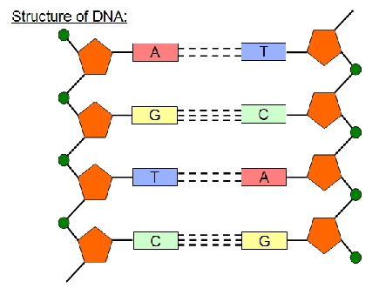

Nitrogen
Bases

Phosphate

DNA Structure: CLUE 2

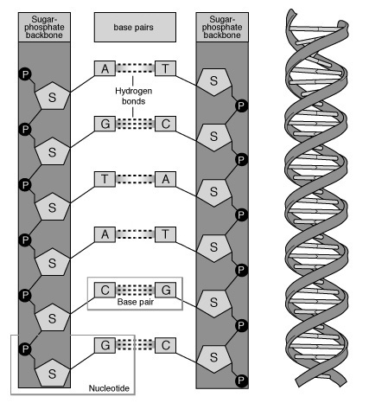
What patterns do you see in regards to the “backbone”?

The ______________________ and _______________________ alternate to make up the backbone. This is called the backbone because________________
________________________________________________________________________________________________________________________________________________________________________________________________________________________________________________________.

What is a nucleotide made up of?

What is the difference between a nitrogen base and a nucleotide?

What connects nucleotides together?

What connects nitrogen base pairs together?

DNA carries genetic information. Which part of the nucleotide do you think carries that genetic information? Explain

Nitrogen Base

DNA Structure: CLUE 3

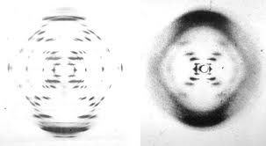
From the evidence of several scientists and Rosalind Franklin’s Xray (shown to the left), Watson and Crick discovered the 3-D structure of DNA.

Can you find a pattern between the X-ray and DNA double helix below? Explain

Does the base-pairing rule fit the DNA double helix model?

Does the Sugar-Phosphate backbone fit the DNA double helix model?

What have you learned about DNA structure?

Why would you imagine the discovery of this structure be important?

http://cmgm.stanford.edu/biochem/biochem201/Slides/DNA%20Structure/015%20A+B%20DNA%20X-Ray%20Diffract.JPG

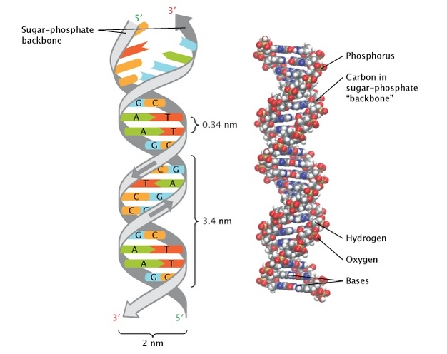

http://www.nature.com/scitable/topicpage/discovery-of-dna-structure-and-function-watson-397

Read Crick’s letter to his son below. Use the letter to make sure that your answers are correct for each of your clues.

http://newswatch.nationalgeographic.com/2013/04/11/francis-cricks-letter-to-son-describing-dna-auctioned/http://newswatch.nationalgeographic.com/2013/04/11/francis-cricks-letter-to-son-describing-dna-auctioned/

My Dear Michael,
Jim Watson and I have probably made a most important discovery. We have built a model for the structure of de-oxy-ribose-nucleic-acid (read it carefully) called D.N.A. for short. You may remember that the genes of the chromosomes — which carry the hereditary factors — are made up of protein and D.N.A.
Our structure is very beautiful. D.N.A. can be thought of roughly as a very long chain with flat bits sticking out. The flat bits are called the “bases”. The formula is rather like this.

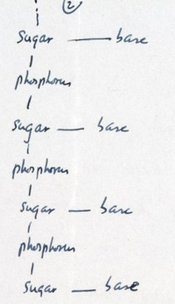 (REFER to your answer On CLUE 2 regarding DNA backbone)

Now we have two of these chains winding round each other — each one is a helix — and the chain, made up of sugar and phosphorus, is on the outside, and the bases are all on the inside. I can’t draw it very well, but it looks like this.

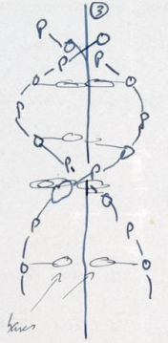 The model looks much nicer than this. (REFER to your answer On CLUE 3 regarding DNA helix.)

Now the exciting thing is that while these are 4 different bases, we find we can only put certain pairs of them together. These bases have names. They are Adenine, Guanine, Thymine & Cytosine. I will call them A, G, T and C. Now we find that the pairs we can make — which have one base from one chain joined to one base from another — are only A with T and G with C.
Now on one chain, as far as we can see, one can have the bases in any order, but if their order is fixed, then the order on the other chain is also fixed. For example, suppose the first chain goes (look below ) then the second must go

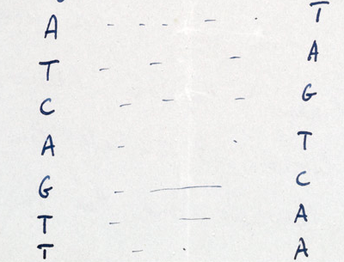 (REFER to your answer On CLUE 1 regarding DNA base pairs)

It is like a code. If you are given one set of letters you can write down the others.
Now we believe that the D.N.A. is a code. That is, the order of the bases (the letters) makes one gene different from another gene (just as one page of print is different from another). You can now see how Nature makes copies of the genes. Because if the two chains unwind into two separate chains, and if each chain then makes another chain come together on it, then because A always goes with T, and G with C, we shall get two copies where we had one before.

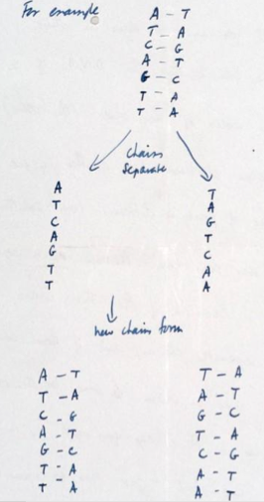

In other words we think we have found the basic copying mechanism by which life comes from life. The beauty of our model is that the shape of it is such that only these pairs can go together, though they could pair up in other ways if they were floating about freely. You can understand that we are very excited. We have to have a letter off to Nature in a day or so. Read this carefully so that you understand it. When you come home we will show you the model.
Lots of love, Daddy

